CS311 DSA Project 3

Your Name: _ ___ Univ. ID: _

Instructions
- Demo deadline: lab class today, Submission deadline: check due date on course webpage
- Remember to comment your code
- Remember to take screenshots of the running results
- Zero mark will be given if your program does not compile, or gets into an infinite loop (does not terminate)
- Submission guide
  - Create a new folder named with CS311_Proj3_yourID
  - Archive your code files and this .doc file into CS311_Proj3_yourID.zip (or .rar)
  - Submit the archived file to cs_scu@foxmail.com

Problems
A minimum spanning tree (MST) or minimum weight spanning tree for a weighted, connected, undirected graph is a spanning tree with a weight less than or equal to the weight of every other spanning tree.
Consider the following graph as an example, write an algorithm to find the MST of the graph.

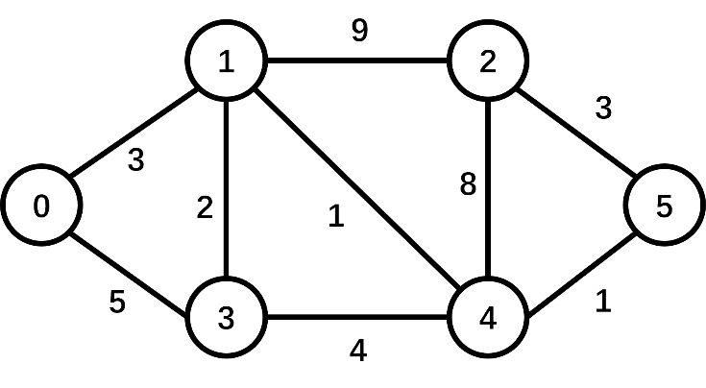

What to turn in
- A .cpp file that includes your codes for MST.
- This .doc file.
How to turn in
See 'Submission guide' above.

PROJECT REPORT

Your Solutions
Show your ideas, and the process to find the MST (no need to show your code here).
Some screenshots of the results of your program's execution.
Here’s a report of the solution:

Implementation of Kruskal's Algorithm for MST

Introduction
The purpose of this report is to describe the implementation of Kruskal's algorithm for finding the Minimum Spanning Tree (MST) of a weighted, undirected graph. Kruskal's algorithm is a classical greedy algorithm that selects edges in increasing order of weight, ensuring no cycles are formed, until all vertices are connected. This algorithm is efficient for sparse graphs and is implemented using a Union-Find (Disjoint-Set) data structure to manage the connected components.

Problem Statement
Given an undirected graph with vertices and weighted edges, the goal is to find a subset of edges that connect all vertices, with the minimum possible total weight, forming the MST.
Approach

The solution follows these steps:
- Sorting the Edges: The edges of the graph are sorted in ascending order of their weights. This ensures that the algorithm considers the lightest edges first, which is key to Kruskal's greedy approach.
- Union-Find Data Structure: To efficiently check for cycles and merge disjoint components, a Union-Find data structure is used. This allows for quick determination of whether two vertices belong to the same component (using the find function) and for merging components (using the unionSet function).
- Building the MST: Starting from the smallest edge, the algorithm iterates through the sorted edges. For each edge, it checks if the two vertices connected by the edge are already in the same component. If they are not, the edge is added to the MST, and the components of the two vertices are merged.
- Termination: The process continues until the MST contains V-1 edges (where V is the number of vertices), which is the characteristic of any tree.

Code Explanation

The implementation consists of several key components:
- Edge Structure: Represents an edge in the graph with three fields: source, destination, and weight.
- Sorting Function: A comparison function (compareEdges) sorts the edges based on their weight.
- Union-Find Operations: The find function performs path compression for efficiency, while the unionSet function merges two components.
- Main Logic: In the kruskalMST function, edges are sorted, and the Union-Find structure is used to progressively build the MST by selecting edges that do not form a cycle.

